Corporate Service Manager

Position Description

Incumbent
Name:
Date Commenced:

Industrial Instrument and Level
Local Government Industry Award 2010

Position Summary
Objectives of the position:

Provide leadership, management, professional advice and support to the Executive Management and Corporate Services teams.

To work in close liaison with the Chief Executive Officer in the day to day management of the Council’s administration and financial operations in accordance with statutory requirements and Council Policy.

Within Section:
Consistently demonstrating the agreed characteristics of Shire staff (our values).

Develop a high performing team by setting and documenting clear expectations for all direct reports, building trust & cohesion within the team by displaying the highest level of integrity & support for individual team members and by challenging staff & celebrating their success.

Within Organisation:
Consistently demonstrating the agreed characteristics of Shire staff (our values),

Provide assistance, advice and information to the Chief Executive Officer, senior staff and Council on administration and financial matters affecting the Shire of Wyalkatchem.

Requirements of the position

Skills
Developed skills in building effective teams.
Numeric literacy and advanced attention to detail.
Computer literacy & experience in the use of financial management software.
Well-developed written and verbal communication skills.
Developed public relations and customer service skills.
Developed problem solving and conflict resolution skills.

Knowledge and experience
Working knowledge of the Local Government Act 1995 and associated regulations.
Working knowledge of local government accounting requirements and procedures including budgeting, financial reporting, rates and procurement practices.
Sound knowledge of information technology including computer systems and software applications.
Sound knowledge of local government records management.
Sound experience in staff supervision.
Sound experience in whole of organisation communication.

Qualifications and/or training
Formal qualifications in Accounting or related discipline or appropriate on the job training and relevant experience.
Hold a current “C” class WA motor vehicle driver’s license.

Key Roles and Responsibilities
The principle responsibility areas of this position are outlined in the table below:
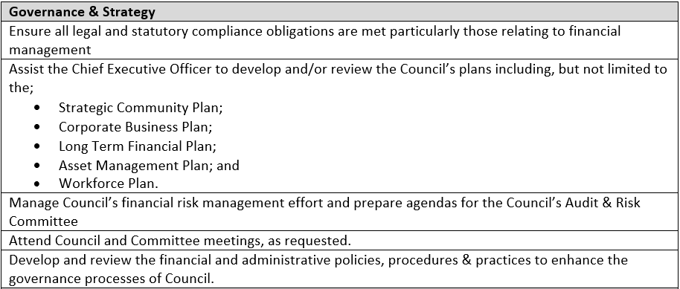
Finance
Control Council’s financial function and compliance with accounting standards in accordance with the Local Government Financial Management Regulations.
Timely preparation of financial reports including the;
- annual budget,
- mid-year budget review and
- monthly financial reports,
- annual financial statements, and
- other statutory & management reports, as requested.
Advise Council, the Chief Executive Officer and senior staff on all matters relating to Council finances.
Oversee compliance with the Council’s procurement policy and support procurement activity, as requested.
Oversee the various functions of the finance team including accounts payable, accounts receivable, payroll and the rating system ensuring that data entry is accurate and payments are made on time and in compliance with internal controls.

Prepare accurate and timely tax reconciliations and returns to meet ATO requirements including periodic BAS statements, FBT and PAYG.
Prepare timely and accurate month end reconciliations.
Prepare periodic reports to enable the Works Manager to track expenditure against budget.
Monitor, process and reconcile Council’s fuel inventor.
Maximise revenue from investments and manage Council’s loan portfolio.
Maintain the Council’s asset register.
Manage the Council’s statutory audits and the implementation of audit findings, as required by the Local Government (Financial Management) Regulations 1996 and Local Government (Audit) Regulations 1996 including;
- Regulation 17 reviews,
- financial management reviews,
- annual external audits; and
- any other external and internal audit functions.
Human Resources
To lead the administration and finance teams to deliver timely services within a supportive, high performance environment.
Set performance, behavioral and training or personal development objectives for all direct reports and formally assess and document progress against these objectives on a periodic basis (at least half yearly).
Oversee the recruitment and selection process for administration and finance staff.
Other
Oversee operations of the Shire of Wyalkatchem Swimming Pool.
Manage the Council’s cleaning services.
Oversee animal control including liaising with Council’s rangers.
Work closely with Council’s consultants to process building and planning applications.
Monitor and maintain Council’s IT hardware & software and ensure its optimum performance & security.

Prepare statistical returns.
Develop submissions and make grant applications where appropriate to assist with the financing of projects and events.
Ensuring adequate insurance cover for all relevant Council assets and activities and promptly process Council’s insurance claims.

Undertake other tasks as requested by the Chief Executive Officer.

Records Management
Oversee compliance with the State Records Act 2000 by ensuring corporate documents are recorded in the Shire’s Record Management Systems.

Customer Service
Deliver a timely, accurate and professional service to internal and external stakeholders via telephone, email, social media and in-person interactions.

Behaviour and conduct
Perform duties efficiently, responsibly and ethically and in accordance with the Shire’s values and Code of Conduct.
Occupational Safety and Health
Promote, foster and enforce safe work practices and Council’s Occupational Safety and Health Policies, principals and procedures throughout the organisation.
Correct or report unsafe situations, workplace incidents, accidents or damage and use safety equipment and devices as specified.
Participate in activities associated with the Management of Workplace Safety.
Use personal protective equipment as required by site procedures or as otherwise required to ensure your safety & the safety of your work colleagues.
Use personal protective equipment as required by site procedures or as otherwise required to ensure your safety & the safety of your work colleagues.

Key Selection Criteria
Essential

- Team leadership – setting & monitoring expectations, mentorship, positive culture development and change management.
- An interpersonal style that creates trusting staff & stakeholder relations, win-win contract negotiations and the de-escalation of conflict.
- A minimum of three years’ experience in delivering financial services within a local government or a small to medium sized enterprise.
- Working knowledge of local government accounting requirements and procedures including budgeting, financial reporting, rates and procurement practices.
- Working knowledge of the Local Government Act 1995, Local Government Financial Management Regulations and the State Records Act.
- Computer literacy & experience in the use of financial management and record keeping software.
- A proven ability to manage the Council’s IT including, security, computer systems (hardware) and software applications.
- Demonstrated experience with the local government rating system.

Desirable
- At Least 5 years or more experience in a similar position within local government.
- Previous experience using software packages SynergySoft and Altus.
- Tertiary qualifications in finance/accounting, commerce or business Management.

Other Requirements
Police Clearance:
Before appointment the successful applicant will be required to provide evidence of a current National Police Certificate, issued by WA Police or the Australian Federal Police if the successful applicant is from interstate. This certificate remains the property of the applicant however, a copy will be kept on the employee’s personal file.

Hold a current “C” class driver’s licence

Organisational Relationships:

Position is responsible to:
Chief Executive Officer

Position supervises:
Finance Officer
Customer Service and Records Officer
Rates Officer
Cleaners (casual)

Key Relationships:
Internal: Chief Executive Officer
Manager of Works
Other Staff and Employees
President and Councillors

External: General Public (including Ratepayers and Residents as appropriate)
Suppliers of goods and services, contractors
Creditors / Debtors
Other Local Governments
Government Departments

Extent of Authority
Operates under the limited direction of the Chief Executive Officer within established guidelines, procedures and policies of Council as well as statutory provisions of the Local Government Act and other legislation.

Public Responsibilities
To promote a favourable public image of Council’s personnel, operations and the Shire in general.

Performance Review
Probation period first three months of employment.
Performance Appraisals conducted at least biannually.

Signed
Corporate Services Manager:
Name:
Signature:
Date:

Corporate Services Manager:
Name:
Signature:
Date:

