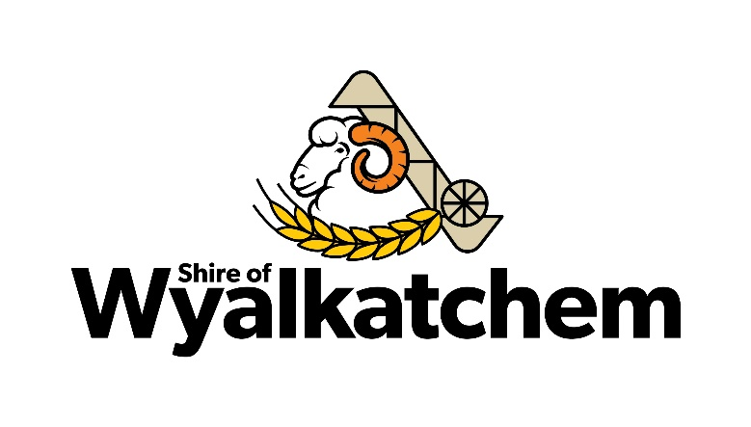
PUBLIC NOTICE
LOCAL GOVERNMENT ORDINARY ELECTIONS 16 OCTOBER 2021
CALL FOR NOMINATIONS

Nominations are called for the Shire of Wyalkatchem Extraordinary Elections to be held on Saturday 16 OCTOBER 2021 to fill the following vacancies on the Council of the Shire of Wyalkatchem:
- District One (1) Vacancy Term Expiring October 2023
- District Four (4) Vacancies Term Expiring October 2025

Who can nominate?
Any person who is an Australian Citizen over the age of 18 years who is an elector of the district and is not disqualified under the Local Government Act 1995 may nominate for Council.

Nomination Time and Place
Nominations open on Thursday 2 September and close at 4.00pm Thursday 9 September 2021.
Nominations must be lodged with the Returning Officer (CEO Peter Klein) at any time during the above period at the Shire Wyalkatchem 27 Flint Street, Wyalkatchem WA 6485.

Nomination Requirements
Candidates are required to lodge with the Returning Officer:
- A completed nomination in the prescribed form, signed and witness.
- A single A4 page profile containing not more than 800 characters of biographical information about the proposed candidate and statements of the candidate’s policies or beliefs.
- A nomination deposit of $80
- A recent passport-size photograph (optional)

To nominate, every individual must complete the mandatory online candidate induction module available via the Department of Local Government, Sport and Cultural Industries website at www.dlgsc.wa.gov.au.au

Where an agent lodges a nomination on a candidate’s behalf, it must be in the prescribed form with a written authorisation signed by the candidate.

The documents may be hand delivered, posted or faxed to the Returning Officer and must be received by the close of nominations.
Information packages about the requirements for becoming a Councillor, the election process and copies of the prescribed forms is available at the Shire of Wyalkatchem.

PETER KLEIN
CEO/RETURNING OFFICER
SHIRE OF WYALKATCHEM

